**Experiment-10**

**AIM: Working with .dockerignore**

Building an img3:1.0

This image consists of a Dockerfile and password.txt.

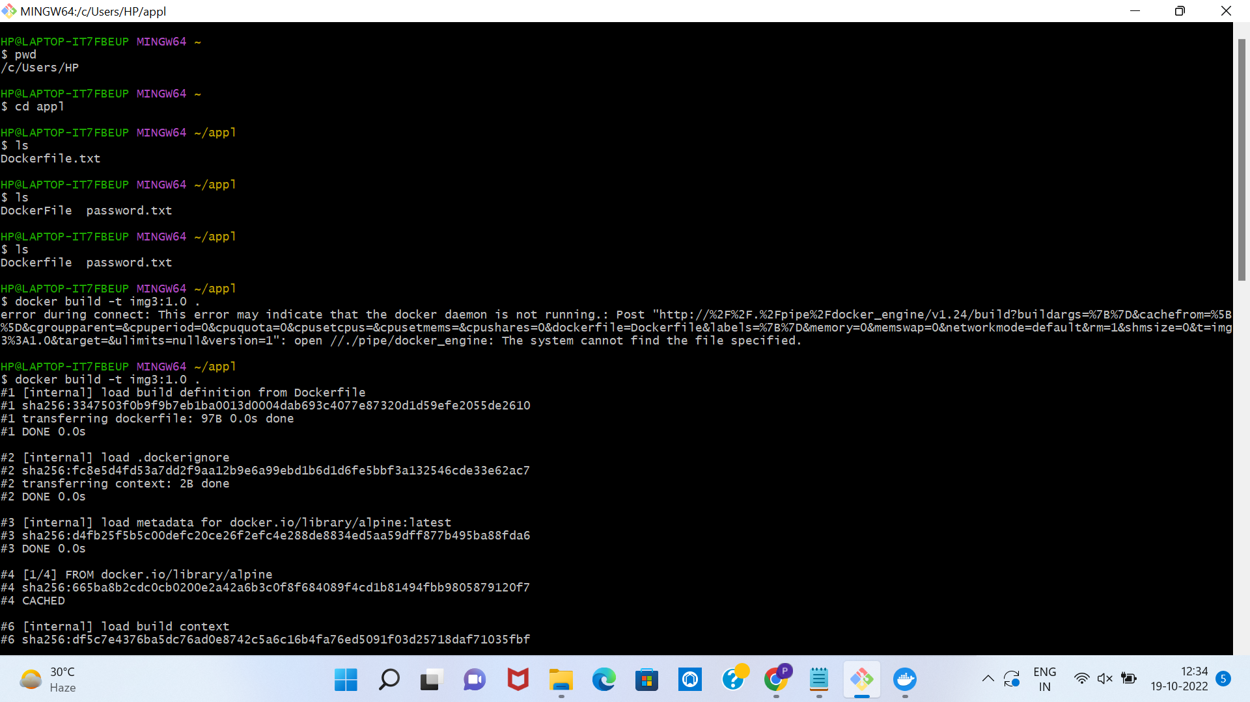

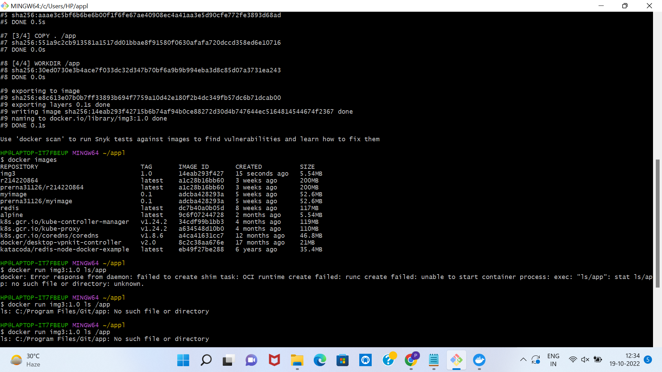

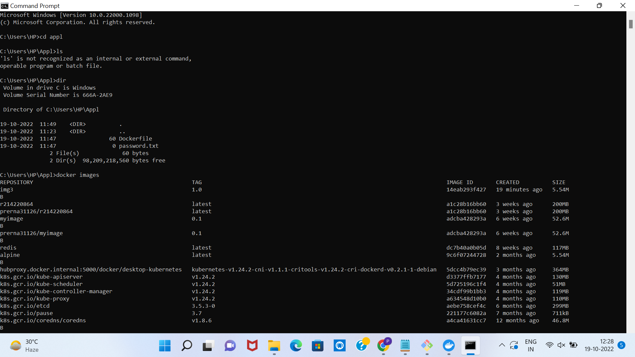

Building an img3:1.0

This image consists of a Dockerfile and password.txt.

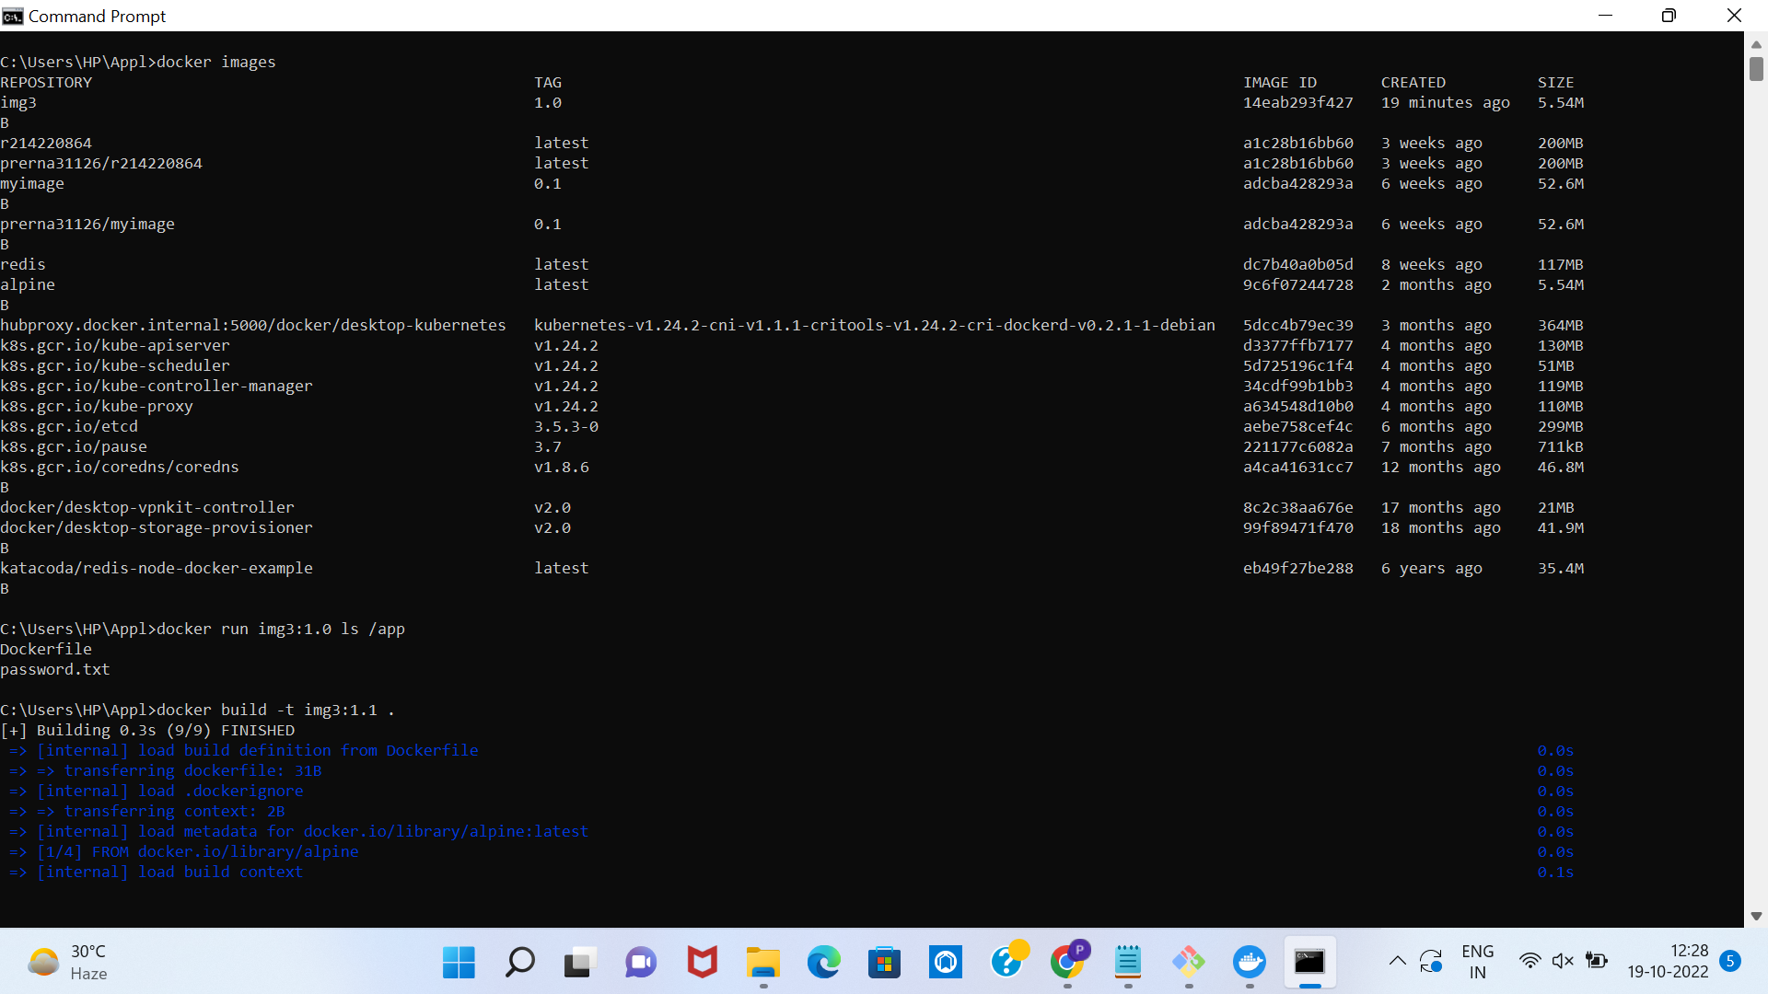

Building an img3:1.1

img3:1.1 consists of Dockerfile ,password.txt and *.png.

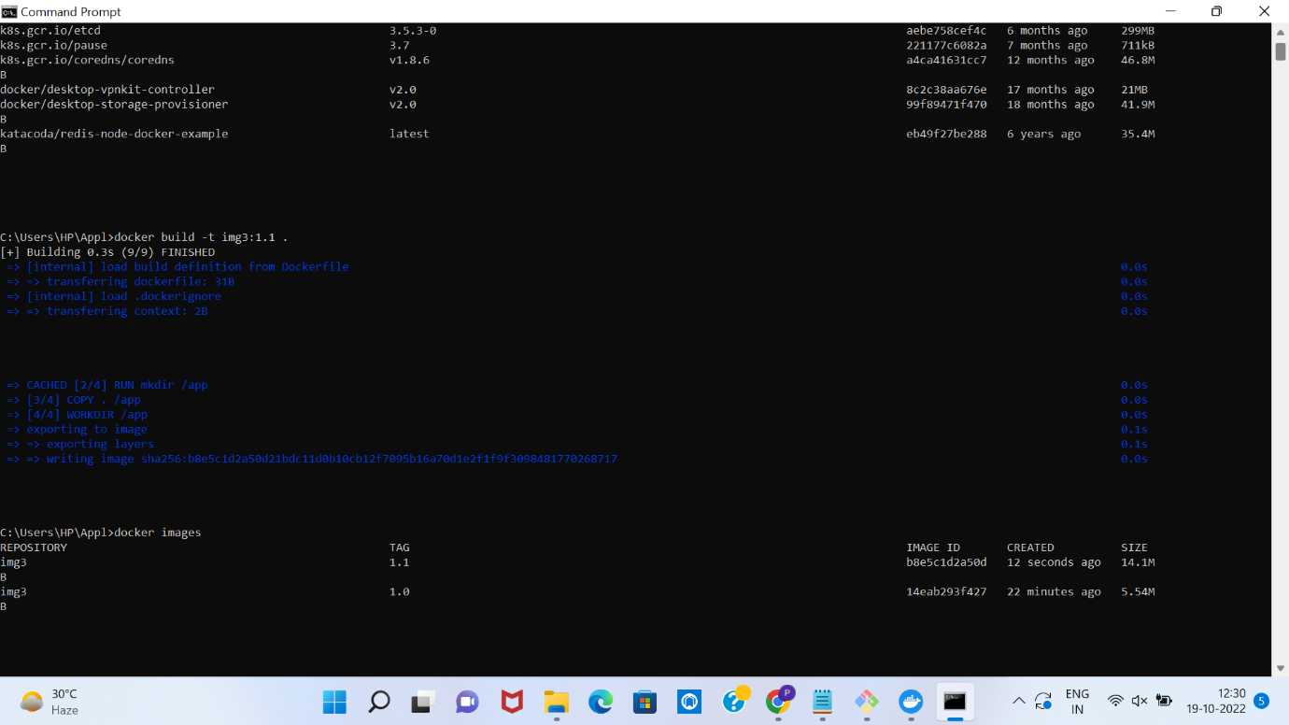

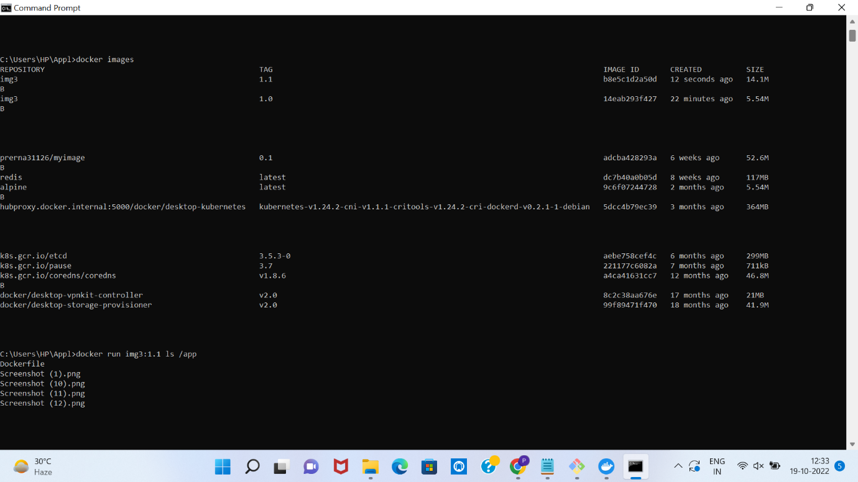

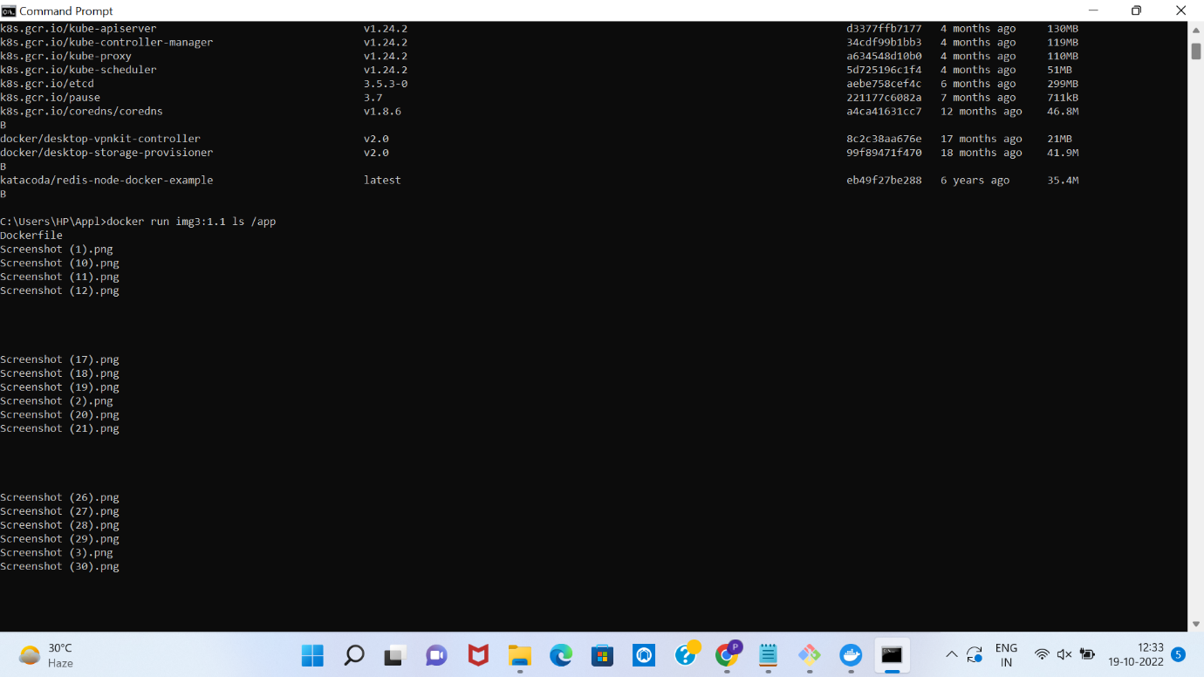

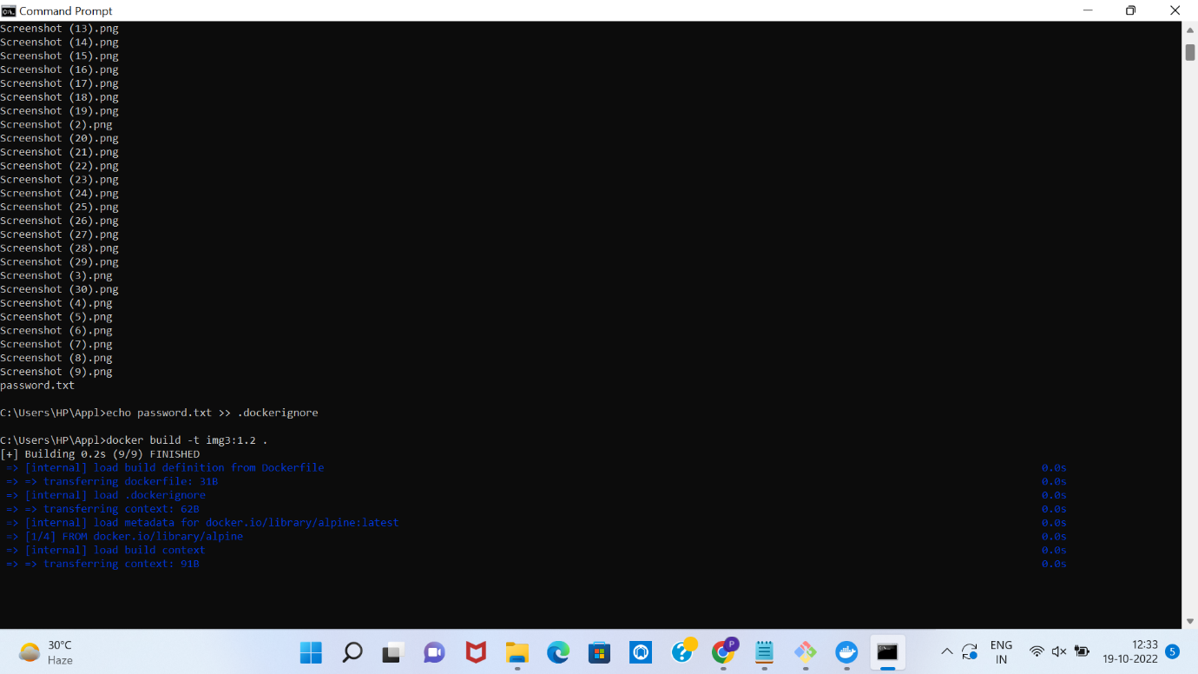

Building an img3:1.2

Img3:1.2 consists of Dockerfile

.dockerfile consists of *.png and password.txt

.dockerignore file is not included while creating an image from a Dockerfile.

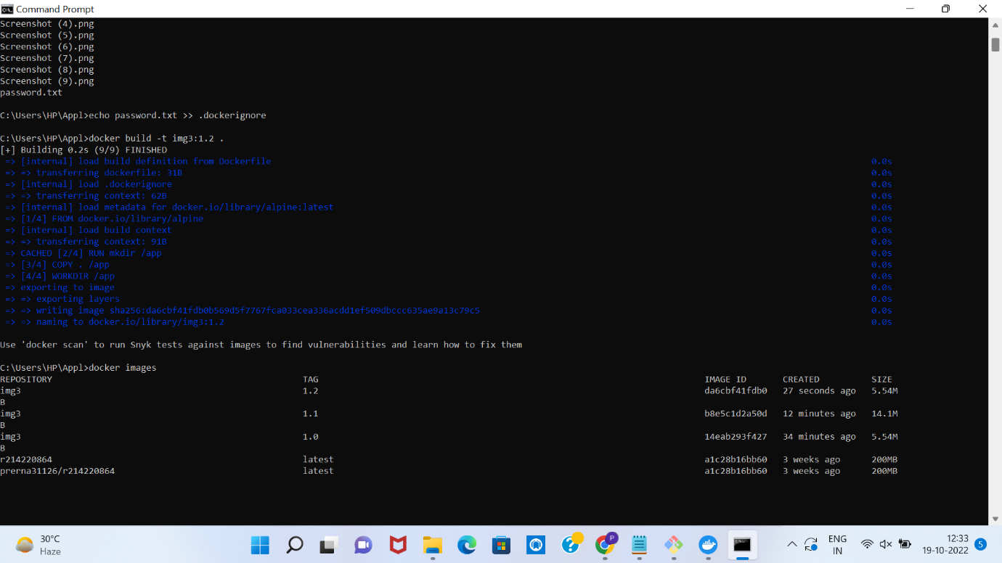

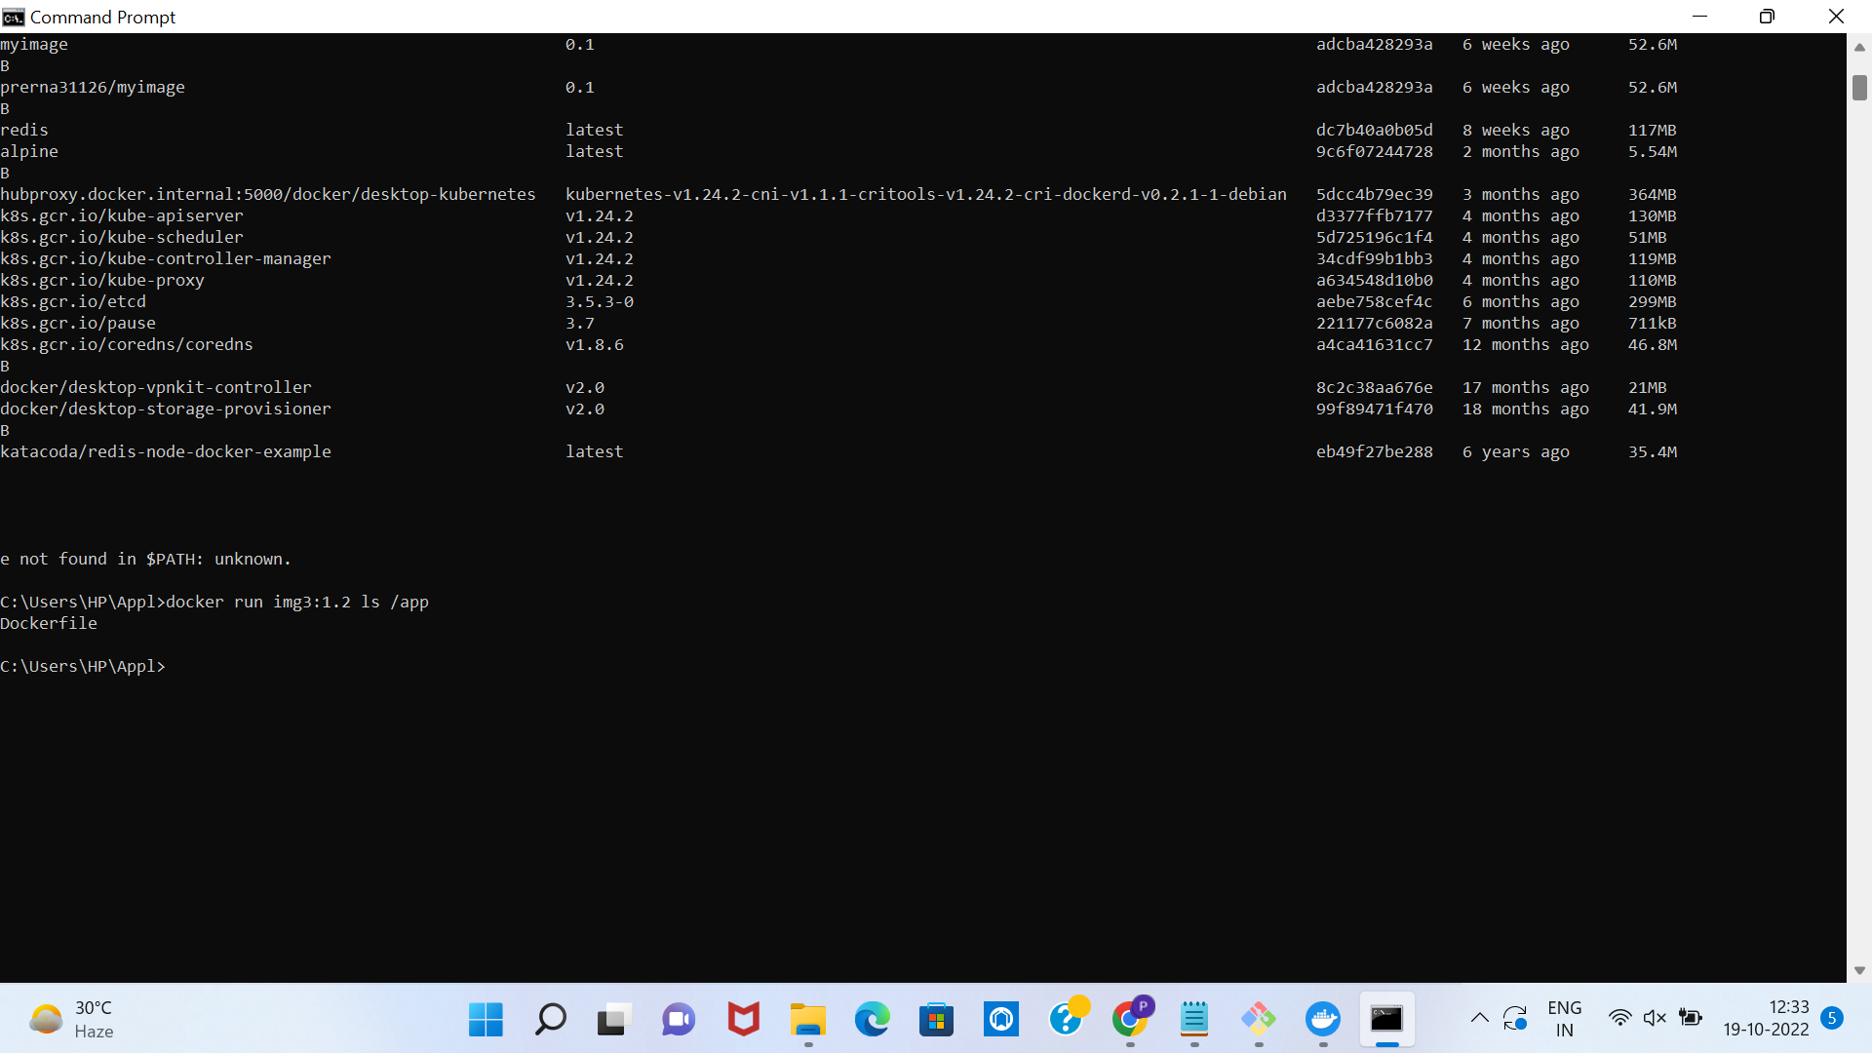

Dockerfile:

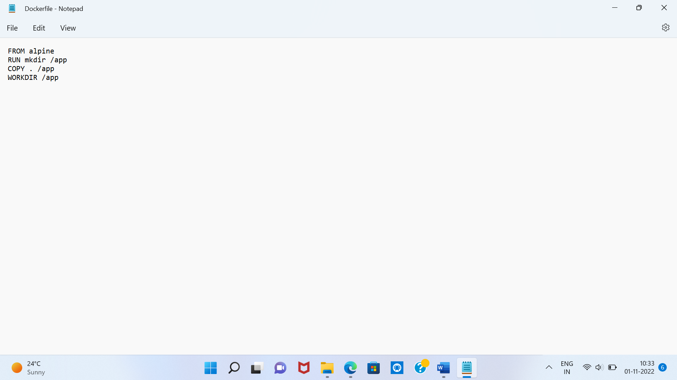

.dockerignore :

